Art Medium-term Plan

Year Group  Year 2 |  | Term  Autumn 1 |  | Unit of Learning  Drawing
About the unit  Children learn how to use pastels to create tonal effects. They will apply what they have learnt when creating the background / landscape for their piece of art work. |  |  | Where the unit fits in  Theme - Dinosaurs  Children are learning about dinosaurs and as part of this they will be learning about habitats. They will think about what the earth was like when dinosaurs were around and will consider this when creating their art work.  This unit of work will link with DT and children will use their DT skills to create a moving element to their art work.
Prior Learning  Children had experience of drawing in proportion through completing step by step drawings of minibeasts in Reception and animals in year 1.  They have explored various mark making materials such as pastels and the effects they can create in independent learning. |  | Vocabulary  Landscape, foreground, background  Materials:  Pastel, draw, smudge, blend  Art elements focused on when creating the background:  Tone - soft, harsh, shade, light, dark  Art elements focused on when drawing the dinosaur and landscape features:  Line - straight, curved  Shape - circular, oval, pointed |  | Resources  Pencil, paper, sketchbooks, pastel, scissors.  Images of skies.
Assessment (By the end of this unit the children will be able to…)

- Use a range of materials creatively to design and make art work.
- Draw to develop and share ideas, experiences and imagination.
- Line - Use a range of materials to explore and make different types of line (curved, thin, thick, bold, vertical, horizontal, diagonal).
- Tone - Create soft and harsh tones in their work.
- Shape and form - Produce 2D work in proportion.
- Colour - Explore colours for their art work.
- Talk about the work of a range of artists, craft makers and designers and make links to my own work.

Learning Objective  Children will: | Possible teaching Activities |  |  |  | Learning Outcomes  Children will have:
Talk about the work of other artists. | Look at examples of digital paleoart. Talk about what can be seen in the foreground and background of the pictures. Talk about the use of light and dark colours and shades. |  |  |  | Observed and discussed the different layers of artwork and the use of tone.
Show their ideas and imagination through exploring tonal pastel effects. | Landscapes. Children decide on what sort of landscape or background they would like for their own dinosaur art work. What do they want it to show? Do they want it to be a peaceful day time scene or a dramatic sunset? Do they want it to be night time? Will it have trees, rocks, mountain or volcano shapes in it?  Show children images of different skies to help them decide. Look at the images and observe light and dark areas and the different colours and shades of colours that there are. Get children to think about the colours they will need to use to create the effect they have chosen.  Tell children that they will create the background and landscape using pastels. Pastels are a great medium in that you can easily cover up mistakes by simply applying another colour over the top and are fun to work with. Different shades of lighter and darker pastels will be needed to create soft and harsh tones in their art work.  Choose a sky image to work from to begin with and demonstrate how to use pastels to create the background tonal sky effect.  Observe where the lighter and darker colours are and apply the lighter colours first to avoid muddying them with the darker colours (lighter colours can be added on top of darker colours later though if needed).  Stage 1 - Application of pastels.  Place all the colours on the paper until around 95% of it is covered with Pastel. Use the side of the pastel if you are covering larger areas so you can cover it quicker. It is not important that it can look untidy at this stage or that there are bits of the paper showing as this will all be covered once the blending has been completed and the appearance is much smoother.  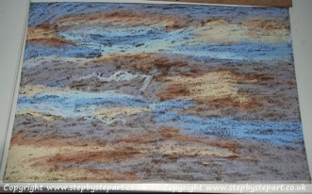  Stage 2 - Blending  Once you have laid down all the Pastel tones, with clean hands begin blending each section individually. You will need to use different fingers for different colours to avoid muddying the colours or clean them in between (but make sure they are dry before blending again). How children blend their pastels is a personal preference but they may find it easier to blend in circular motions.  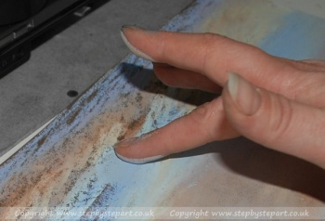  Stage 3 - Additional detail  Once children have completed their blending they may wish to go over any grainy areas where the base paper is still showing through. If children do choose to apply more pastels, they may not need to put on as many layers. Grainier paper will take more layers and may need further layers too.  Once children have finalised their tonal colours and have achieved a smooth finish, this is the part where the finer detail can be added either with pastel sticks or with pastel pencils. Use a light tone of colour to add highlights into the clouds or lighten up those bright sunlit clouds. Ensure transitions of colour are blended together well to avoid harsh edges which can spoil the effect.  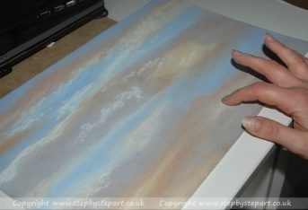  Let children explore and experiment with pastels to create different sky effects in their sketchbooks, before deciding on a sky for their piece of work. They can use images to support this and / or try out their own ideas. |  |  |  | Developed skills in using pastels and experimented with tone.
Show your ideas and imagination through drawing. | Children decide whether to add other landscape details such as trees, mountains, rocks and volcanoes and practise drawing these in their sketchbooks first. Teacher to demonstrate how to draw these if needed.  Children decide whether they will draw straight onto their background with pastels (they could see what this would look like by trying it out in their sketchbooks) or draw them separately to be cut out and added later on to their background. |  |  |  | Made decisions about what they want to include in their artwork through developing their own ideas.
Apply what they have learnt about tone and the use of pastels to create the background for their final piece of art work. | Children complete their backgrounds. |  |  |  | Applied their knowledge and skills.
Use lines effectively to create desired shapes in proportion. | Children follow step by step instructions for how to draw a Tyrannosaurus Rex. If they have chosen to create a night time scene they may want to do this using white crayon on black paper to create a silhouette effect. Once they cut the outline shape out they can turn it over to avoid seeing the white lines. |  |  |  | Used different lines and shapes in proportion to produce an image.
Describe the differences and similarities between art work and talk about your own work. | Children evaluate their finished art work and talk about the tones they have used. They will talk about what they like it about it and what they might change. They could compare their art work with a friends. |  |  |  | Described art elements in their own work and give their opinions.

Take a photograph of the children's finished art work to include in their sketchbooks.

