Art Long-Term Plan 2022-23
Equipping Children for a World of Possibilities

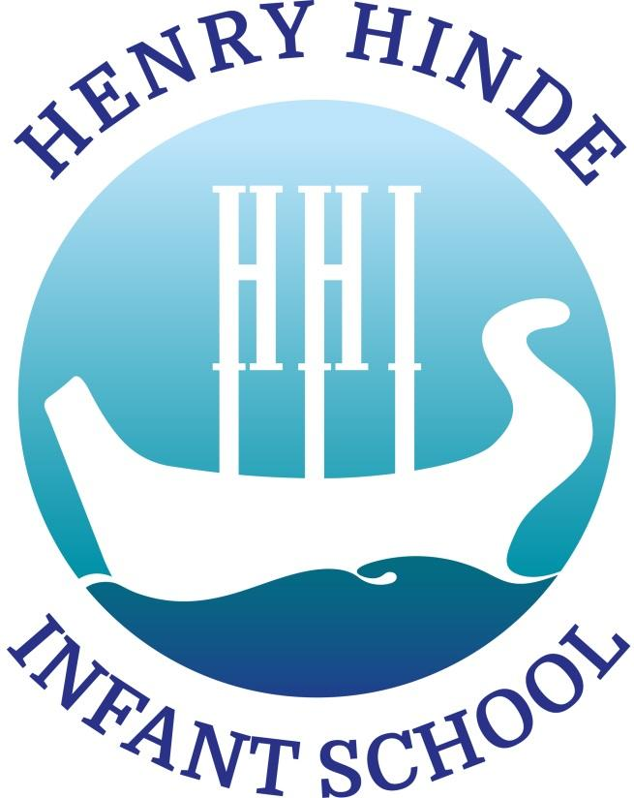
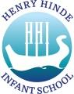
ART INTENT

Curriculum Intent: Equipping Children for a World of Possibilities.

Art Subject Intent:
To use art and the world around us to inspire children and equip them with the knowledge and skills to develop their creativity and the artists within them.

ART IMPLEMENT

Art is taught in blocks in order for children to develop a greater understanding of the art and the process of developing ideas and skills before producing a final piece. In each year group Art is taught over a block of lessons each term. Within each block of learning children learn about an artist, gain inspiration from theme stimuli / ideas and the world around them, develop art skills and gain an understanding of art elements. They talk about their art work and the art work of others and develop their opinions. Children are taught art through whole class inputs and then skills, knowledge and ideas are developed either in groups or whole class teaching sessions, where it is relevant. In Reception, opportunities are provided through continuous provision for children to access art activities and develop and apply their ideas, skills, knowledge and understanding.

All children have a sketchbook in which to develop their ideas and practise skills. Finished pieces of work are included or photographed and put in the sketchbooks. Children take their sketchbooks with them to their next year group as they progress through school. This helps them to build on skills learnt and develop ideas, showing the progress they have made.

All children take part in a whole school arts week, that takes place at some point in the year. The arts week is based on a particular artist / group of artists, type of art or focus. All children produce work based on the same theme, artist or skill, but learning is differentiated depending on the year group or needs of the child. The finished artwork is displayed in a temporary art gallery that the children’s families and friends are invited to visit.

Children’s art work is displayed around school in year group areas and particular pieces are chosen to be displayed in the school art gallery.

Children are introduced to an artist of the term. This is the same artist for each year group which may or may not relate to the art learning taking place in one of the year groups. Classes are sent a picture of the artist and one or two pictures of art work for children to talk about and give opinions of. Children are encouraged to think about the media used and comment on the work using vocabulary that demonstrates their knowledge of the art elements. Children are encouraged to develop opinions about the artwork and are invited to produce their own art work, inspired by the artist, at home. These may be shared and displayed in school.

Children have the opportunity to take part in arts and crafts clubs if they are running in their year group. At present children are not allowed to cross year group bubbles so the opportunities are more limited.

Art Curriculum

Reception

EYFS curriculum (Development Matters 2020 and Early Learning Goals ELG):
Expressive Arts and Design Development Matters Three and Four Year Old statements
- Explore different materials freely, in order to develop their ideas about how to use them and what to make.
- Develop their own ideas and then decide which materials to use to express them.
- Join different materials and explore different textures.
- Create closed shapes with continuous lines, and begin to use these shapes to represent objects.
- Draw with increasing complexity and detail, such as representing a face with a circle and including details.
- Use drawing to represent ideas like movement or loud noises.
- Show different emotions in their drawings and paintings, like happiness, sadness, fear etc.
- Explore colour and colour-mixing.
Expressive Arts and Design Development Matters Reception statements:
- Explore, use and refine a variety of artistic effects to express their ideas and feelings.
- Return to and build on their previous learning, refining ideas and developing their ability to represent them.
- Create collaboratively sharing ideas, resources and skills.
Creating with Materials ELG
- Safely use and explore a variety of materials, tools and techniques, experimenting with colour, design, texture, form and function.
Share their creations, explaining the process they have used.

Key Stage 1

Key Stage 1 National Curriculum Art statements
Subject content
Key stage 1 pupils should be taught:
- to use a range of materials creatively to design and make products
- to use drawing, painting and sculpture to develop and share their ideas, experiences and imagination
- to develop a wide range of art and design techniques in using colour, pattern, texture, line, shape, form and space
about the work of a range of artists, craft makers and designers, describing the differences and similarities between different practices and disciplines, and making links to their own work.

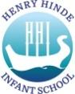
Skills Progression

 | Being an artist | Drawing | Painting | Printing | Sculpture | Art in Context / History
All children should be given the opportunity to: | Observe, explore and imagine. | Draw on different surfaces with different materials e.g., pencils, felt tips, charcoal, crayons, chalk and pastel. | Use a variety of different brushes and mark making tools for painting. | Experiment with shape and pattern and use different materials to create texture. | Use a variety of materials for sculpting (paper, card, clay, straw etc) and experiment with joining and constructing. | Learn about a wide variety of artists, designers and crafts makers.
Assessment Criteria
Reception | - I can describe what I can see. | - I can create marks with a variety of media, tools and materials.  - I can draw straight and curved lines and use them in my drawings. | - I can explore what happens when I mix colours.  - I can experiment with paint e.g., creating textured paint | - I can use a variety of materials to print with. | - I can cut, roll, coil and join materials to make a sculpture. | - I can describe what I can see in a piece of art work.  - I can give an opinion about the work of an artist, crafts maker or designer.
At depth | Children will comment on the elements of art and the effect they have. They may compare what they can see with things they know. | Children will apply and develop the skills independently. They will have their own ideas of how to use the skills and techniques learnt and developed. Through investigations and experimentation, they will develop new ideas. |  |  |  | Children will comment on the elements of art and the effect they have. They will give thoughtful and rational reasons for their opinions.
Year 1 | - I can explore ideas and collect information to inform my artwork. | - I can make different marks: dots, dashes, scribbles, sweeping lines, wavy lines, straight lines.  - I can create lines of different thickness. | - I can hold a brush correctly and experiment with different brush types to make different marks: lines, blobs, dots, dashes.  - I can mix primary colours to make secondary colours and describe how to make them. | - I can create a repeating pattern in print. | - I can use and develop a variety of techniques, e.g., rolling, cutting, pinching, joining. | - I can describe the work of artists, craft makers and designers and express my opinion on the work.  - I can use inspiration from artists, craft makers and designers to create my own work.
Year 2 | - I can try different materials and methods when exploring my ideas to improve my art work. | - I can use dots and lines to demonstrate pattern and texture.  - I can create tones using different grades of pencil. | - I can choose and use different brushes for different purposes.  - I can add white and black to alter tints and tones. | - I can create a printed piece of art by pressing, rolling, rubbing and stamping. | - I can use a variety of shapes, lines and textures in my sculptures. | - I can compare the work of different artists, craft makers and designers and talk about their different practises and disciplines.  - I can use inspiration from artists, craft makers and designers to create my own work and compare it.
At depth | Children will take more responsibility for collecting ideas and information and will explore ideas independently and in more detail / variety. | Children will display a higher level of technical skill with a broad range of tools and media and will be able to apply these independently. They will have their own ideas of how to use the skills and techniques learnt and developed. Through investigations and experimentation, they will develop new ideas. |  |  |  | Children will comment on the elements of art and the effect they have. Children will have a greater breadth of knowledge about artists and key art movements and adapt ideas and process into their own art. Children are more analytical when evaluating their work.

