Pupil premium strategy statement

This statement details our school’s use of pupil premium (and recovery premium for the 2023 to 2024 academic year) funding to help improve the attainment of our disadvantaged pupils.

It outlines our pupil premium strategy, how we intend to spend the funding in this academic year and the effect that last year’s spending of pupil premium had within our school.

School overview
Detail | Data
School name | Henry Hinde Infant School
Number of pupils in school | 148
Proportion (%) of pupil premium eligible pupils | 43 29.5%
Academic year/years that our current pupil premium strategy plan covers (3 year plans are recommended) | 2021-2022  2022-2023  2023 - 2024
Date this statement was published | December 2023
Date on which it will be reviewed | July 2024
Statement authorised by
Pupil premium lead | Becky O’Neill
Governor / Trustee lead
Funding overview
Detail | Amount
Pupil premium funding allocation this academic year | £ 62,565
Recovery premium funding allocation this academic year | £7,105 (Dec 23 estimated total)
Pupil premium funding carried forward from previous years (enter £0 if not applicable) | £ 0
Total budget for this academic year  If your school is an academy in a trust that pools this funding, state the amount available to your school this academic year | £69,670

Part A: Pupil premium strategy plan

Statement of intent
Our pupil premium funding sets the achievements of children from disadvantaged backgrounds as a priority within our school system. We strive to close the attainment gap between disadvantaged pupils and their peers. This is an important gain for these pupils as often they are more likely to be working at a lower attainment than other children and this can impact on their long-term goals. We will consider the challenges faced by a number of our vulnerable pupils, such as those who have a social worker or are asylum seeking learners. The activity we have outlined in this statement is also intended to support their needs, regardless of whether they are disadvantaged or not.
High-quality teaching is at the heart of our approach, with a focus on areas in which disadvantaged pupils require the most support. This is proven to have the greatest impact on closing the disadvantage attainment gap and at the same time will benefit the non-disadvantaged pupils in our school. Implicit in the intended outcomes detailed below, is the intention that non-disadvantaged pupils’ attainment will be sustained and improved alongside progress for their disadvantaged peers. Our strategy is also integral to wider school plans for intervention, notably the implementation of targeted support through the National Tutoring Programme.
Our approach will be responsive to common challenges and individual needs, rooted in robust diagnostic assessment. The approaches we have adopted complement each other to help pupils excel. To ensure they are effective we will strive to –
- Remove barriers to learning
- Act early to intervene at the point need is identified
- Sustain and accelerate the progress of disadvantaged pupils from their relative starting points
- Narrow the attainment gaps between disadvantaged and their peers
- Prioritise early number knowledge and skills to develop pupil’s fluency in basic number
- Prioritise early reading skills so that pupils are able to read fluently and with a good level of comprehension to enable them to access the full breadth of the curriculum
- Enable pupils to be ready to learn and build their resilience
- Equip our pupils with communication and language skills to communicate confidently
- Address non-academic barriers to attainment such as ACES, SEMH needs, behaviour, attendance and punctuality. We will be implementing a new Positive Behaviour policy and developing the interventions that we provide to support promoting punctuality and attendance.

Challenges
This details the key challenges to achievement that we have identified among our disadvantaged pupils.
Challenge number | Detail of challenge
1 | There is an attainment gap between PP pupils and non PP pupils at the end of KS1 in R/W/M at ARE and GD.
2 | Children lack the experiences and vocabulary required of the current curriculum. This is particularly evident in the early years where speech and language is lower than expected on entry. There is also an increase of pupils with EAL from families with Refugee or Asylum Seeker status.
3 | There is a gap in the retention and application of basic number facts/fluency in early number between PP and non PP pupils.
4 | Significant proportion of pupils do not arrive at school ready to learn due to previous ACEs and lower levels of language which results in them lacking confidence, self esteem and often an inability to self-regulate – a significant proportion are PP.
5 | Social and emotional experiences significantly impact the education of a child. This can include the impact of mental health on the pupils and their families. There are increased incidents of high level behaviour which disrupts learning.
6 | Attendance and punctuality is lower in our DAP and pupils with Asylum Seekers Status.

Intended outcomes
This explains the outcomes we are aiming for by the end of our current strategy plan, and how we will measure whether they have been achieved.
Intended outcome | Success criteria
To increase attainment and rates of progress in the acquisition and application of phonic knowledge in order to improve reading (and spelling) skills. | Attainment in 2023/24 Y1 Phonics screening for all pupils will be at least national. (79% 2023)  Attainment in 2023/24 Y1 Phonics screening for disadvantaged will be at least national.  Year 2 attainment in PSC 2023/24 will be at least national (89% 2023)
To improve oracy in Reception through WellComm Interventions which in subsequent years will impact positively in KS1.  To increase pupil confidence to communicate confidently and effectively in a wide range of contexts. Language and vocabulary development will have expanded in order to improve outcomes and secure cultural capital for all pupils including disadvantaged | At least 70% of EYFS cohort achieve ELG in communication/Oracy skills.  Assessments and observations will indicate significantly improved oral language and subject-specific vocabulary among disadvantaged pupils. This is evident when triangulated with other sources of evidence, including engagement in lessons and book scrutiny.
Improved attainment of all pupils including disadvantaged in Reading | All children identified as on track for ARE achieve ARE at the end of the year.  Whole school reading outcomes in 2023/24 will maintain at least 70% of disadvantaged pupils met the expected standard.
Improved attainment of all pupils including disadvantaged in Writing | All children identified as on track for ARE achieve ARE at the end of the year.  Whole school writing outcomes in 2023/24 show that more than 50% of disadvantaged pupils met the expected standard.
Improved attainment of all pupils including disadvantaged in Maths. | All children identified as on track for ELG/ARE achieve ARE at the end of the year.  Whole school maths outcomes in 2023/24 show that more than 70% of disadvantaged pupils met the expected standard.
To equip all pupils with the knowledge and skills to demonstrate fluency in calculation and a confidence and flexibility with number – continue with Mastering Number programme. | All children identified as on track for ELG/ARE achieve ARE at the end of the year.  Whole school maths outcomes in 2023/24 show that more than 70% of disadvantaged pupils met the expected standard.
To provide a clear and consistent Positive Behaviour policy. | A new whole school Positive Behaviours policy will be developed to implement on both school sites to provide consistency for all stakeholders.
To improve all pupil’s social skills and emotional well-being by implementing strategies to address emotional, social and behavioural needs so that pupils are ready to learn. | All staff will follow the Positive Behaviours Policy to use a restorative approach to understanding and managing behaviour needs.  There will be a decrease in instances which require the removal of a pupil from the classroom to the Quiet Room.  There will be a decrease in the involvement of SLT to de-escalate pupils.  PP pupils will have equal access to Extra-curricular activities to promote higher levels of engagement – half termly monitoring  All pupils will arrive at school and access support/strategies which allow them emotionally regulate and maintain their readiness for learning.  Support through HSSW will be offered as required to ensure the whole family is being supported and areas of concern are addressed.  Qualitative data from student and parent voice and teacher observations.
Attendance and punctuality for all pupils will improve | PP attendance is at least in line with their peers.

Activity in this academic year details how we intend to spend our pupil premium (and recovery premium funding) this academic year to address the challenges listed above.

Teaching (for example, CPD, recruitment and retention)
Budgeted cost: £ 18,740
Activity | Evidence that supports this approach | Challenge number(s) addressed
Continue baseline assessment of all pupils who join after Rec start to be completed. Birmingham toolkit to be used for any pupils below EXS. | All staff will know the start points and next steps for new pupils. | 1 2 3
Termly data drop and PPM to be held.  (New whole school tracking system to be in place for Dec 2023 data drop) | Discussion based on progress, attainment and specific needs of pupils taking into account achievement academically and SEMH needs. Next steps/interventions to be identified. | 1 2 3
Continue to deliver WellComm Early Years program in Reception. | EEF Oral language interventions +6 | 1 2
Research use of WellComm Primary in Key Stage 1 – Spring/Summer Term 2024 (£449) | EEF Oral language interventions +6 | 1 2
PD sessions - Vocabulary for all staff | EEF Oral language interventions +6 | 1 2
Rec, Year 1 and Year 2 Lead participants continue to attend local training workshops to deliver the NCETM Embedding the Impact programme | https://educationendowmentfoundation.org.uk/education-evidence/guidance-reports/early-maths | 1 2 3
Continue to increase capacity at Middle Leadership level to monitor subject | Middle leaders have increased ownership for the planning, delivery and outcomes in their subject. Receiving targeted CPD and coaching from external advisors and Senior Leaders in school and release time regularly to enable this. | 1 2 3
New whole school Positive Behaviours policy to be launched and implemented consistently by all staff – Launch Spring 24  Regular review and reflection as necessary throughout the year. | EEF Behaviour interventions +4  Whitby, M 2018.pdf (ncl.ac.uk) | 4 5
New staff to attend full Team Teach training | EEF Behaviour interventions +4 | 4 5
New staff to attend Read, Write, Inc training | EEF Phonics +5months | 1 2
HLTA to continue to deliver EAL interventions/support.  PD opportunities and planning time to be allocated. Interventions to be delivered across the school to remove barriers for pupils. | EEF Oral language interventions +6 | 1 2

Targeted academic support (for example, tutoring, one-to-one support structured interventions)
Budgeted cost: £31,210
Activity | Evidence that supports this approach | Challenge number(s) addressed
255 hours of NTP to be delivered via school based tutor | https://assets.publishing.service.gov.uk/media/63581a9fe90e0777b4a05561/National_Tutoring_Programme_year_2_-_implementation_and_process_evaluation_-_research_report.pdf | 1 2 3 4 5
SMART group – self regulation techniques – group of 4 run by HLTA | EEF Social-and-emotional-learning +4 months  EEF Behaviour-interventions +4months  EEF – Social and emotional learning +4months | 4 5
Targeted small group or 1:1 Phonics Catch Up sessions | EEF Small-group-tuition +4 months  EEF Teaching-assistant-interventions +4months | 1 2
Targeted small group or 1:1 reading sessions with phonetically matched books | EEF Phonics +5months  EEF Small-group-tuition +4 months | 1 2
Precision teach sessions – common exception words or single sounds | https://www.bangor.ac.uk/psychology/teaching/docs/Precision%20Teaching.pdf  EEF Phonics +5months  EEF Teaching-assistant-interventions +4months | 1 2
Targeted small group maths sessions using the Mastering Number resources to keep up with the class | EEF Teaching-assistant-interventions +4months  EEF Mastery-learning +5months | 3
Our Home School Support Worker will support the needs of individual children in a mentoring role with 1:1 or small group sessions in response to instances that arise | EEF Mentoring +2 months | 4 5
Other necessary TA/Class teacher led interventions where need arises throughout the year.

Wider strategies (for example, related to attendance, behaviour, wellbeing)
Budgeted cost: £ 20,000
Activity | Evidence that supports this approach | Challenge number(s) addressed
Family Support Worker engages with vulnerable families across school offering a range of support. | EEF parental Engagement +4 | 1 2 3 4 5 6
Disadvantaged pupils will have access to a wide range of enrichment experiences both in the classroom and outside of it to increase their cultural capital which will be fully funded | EEF parental Engagement +4 | 1
Disadvantaged pupils will have access to a wide range of fully funded extra-curricular clubs which will support their well-being and increase their cultural capital | EEF Physical-activity +1 | 4 5 6
School Attendance team track, monitor and implement attendance policy daily. | Working together to improve school attendance (publishing.service.gov.uk) | 6
Attendance Lead to meet termly with TSO from Warwickshire to discuss PA and SA. Targeted action plans to be reviewed. | Working together to improve school attendance (publishing.service.gov.uk) | 6
Three week schedule for attendance monitoring meetings between Vice Principal, HSSW and Admin to embed principles of good practice set out in the DFE’s Working together to improve school attendance (publishing.service.gov.uk) and school Attendance policy. | Working together to improve school attendance (publishing.service.gov.uk)  Outcomes cannot improve if attendance is poor. Supporting families to get children in to school, educating them on keeping the children well and holding them to account for their child’s attendance. | 6
Parent workshops to increase engagement with families – Maths, Phonics, Computing with particular focus on ensuring the attendance of PPG/vulnerable families. | EEF Parental engagement +4 months | 4 5 6

Total budgeted cost: £69,670

Part B: Review of outcomes in the previous academic year

Pupil premium strategy outcomes
This details the impact that our pupil premium activity had on pupils in the 2022 to 2023 academic year.

Objective | Outcome/impact
- To increase attainment and rates of progress in the acquisition and application of phonic knowledge in order to improve reading (and spelling) skills | Appointment of school led tutor in March (through NTP funding and PPG) had positive impact on interventions.  All year group interventions were delivered consistently and with fidelity.  Y1 screening check  2022 2023  HHIS 79% v Nat76% HHIS 93% v Nat 79%  This is our highest result for six years and is a direct impact of targeted support on the bottom 20% of readers through in class teaching; use of  volunteers and the introduction of a National Tutor through the national tutoring programme.  Boys have outperformed girls for the first time in three years.
- To improve oracy in Reception through WellComm Interventions  - To increase pupil confidence to communicate confidently and effectively in a wide range of contexts. Language and vocabulary development will have expanded in order to improve outcomes and secure cultural capital for all pupils including disadvantaged | ELG 2022 – HHIS v Nat  Speaking  HHIS 88% v Nat 83%  Comm and Language  HHIS 83% V Nat 80%  ELG 2023 – HHIS v Nat  Speaking  HHIS v Nat  Comm and Language  HHIS V Nat
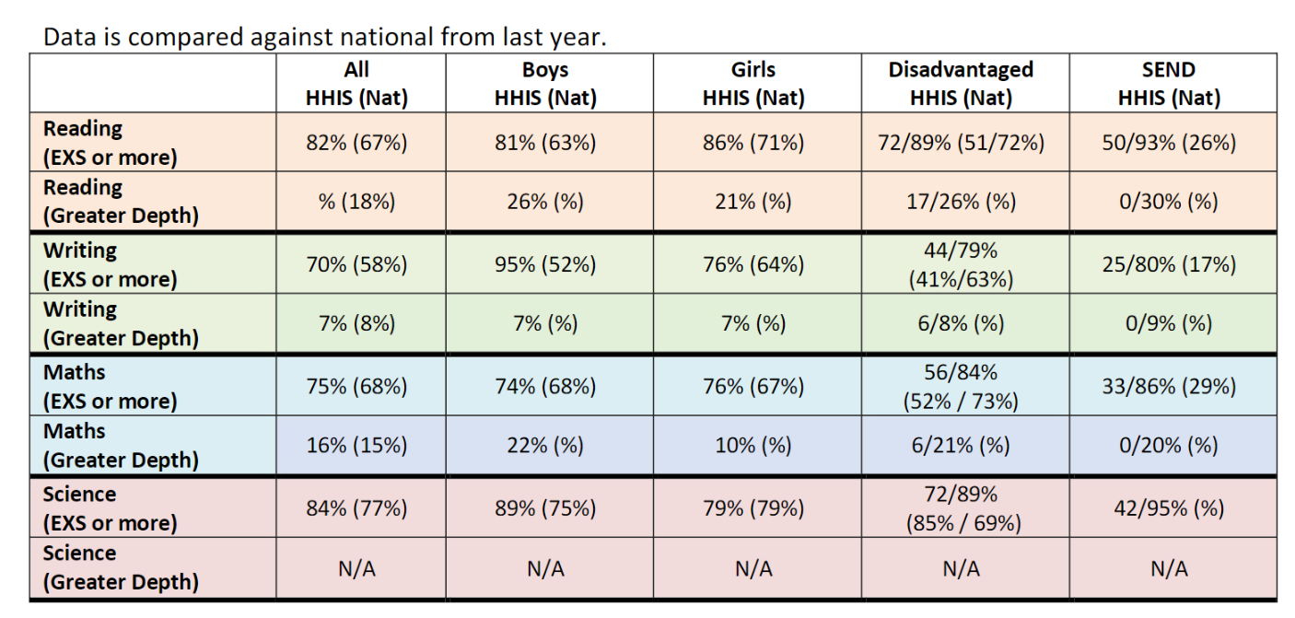
- Improved attainment of all pupils including disadvantaged in Reading | Reading 2023 – HHIS v Nat  EY School was below national by more than 5% in Word Reading.  All KS1 at ARE+ is above national 82%/67% +15%.  All increase of 12% from HHIS 2022.  PPG increase of 14% from 2022.  PPG above national +21%.  This is a direct impact of targeted support on the bottom 20% of readers through in class teaching; use of volunteers and the introduction of a National Tutor through the national tutoring programme.
- Improved attainment of all pupils including disadvantaged in Writing | Writing 2023 – HHIS v Nat  EY School was below national by more than 5% in Word Reading.  All KS1 at ARE+ is above national 70%/58% +12%.  All increase of 20% from HHIS 2022.  PPG increase of 13% from 2022.  PPG above national +4%.  This is a direct impact of targeted support on the bottom 20% of writers through adaptive teaching in whole class lessons, the introduction of a National Tutor through the national tutoring programme and the delivery of small group interventions such as MOVES, handwriting, sentence construction and editing skills.
- Improved attainment of all pupils including disadvantaged in Maths | Maths 2023 HHIS v Nat  EY School was below national by more than 5% Number and Numerical patterns.  All KS1 at ARE+ is above national 75%/68% +7%.  All increase of 19% from HHIS 2022.  PPG increase of 3% from 2022.  PPG above PPG national +4%.  This is a direct impact of targeted support on the bottom 20% of mathematicians through adaptive teaching in whole class lessons, the introduction of a National Tutor through the national tutoring programme and the delivery of small group interventions by the class teacher.  Mastering Number has been used as a whole class fluency session and the resources have been used to deliver keep up interventions in both year 1 and year 2.
- To equip all pupils with the knowledge and skills to demonstrate fluency in calculation and a confidence and flexibility with number | Evaluation documents submitted to NCETM demonstrated continued progress and impact for pupils and staff-  *Subitising skills were more embedded during the year and pupils are entering KS1 with stronger knowledge  *Pupils are able to calculate rather than reliance on counting in ones – less errors  *Stem sentences continue to give greater equity for PPG, EAL and SEN  *Staff confidence continues to increase due to a deepening of subject knowledge, understanding of pedagogical principles and use of carefully matched representations and stem sentences.  *Staff confidently transfer skills and knowledge in the planning and delivery of their main maths lessons.  * Learning walks and pupil voice showed that children were engaged in Mastering Number sessions. Staff build in opportunities to refer to and build on known skills.
- To improve all pupil’s social skills and emotional well-being by implementing strategies to address emotional, social and behavioural needs so that pupils are ready to learn | *Pupils regularly refer to Zones of Regulation to convey how they are feeling even though they may not be able to identify and name the emotion.  *External QA pupil voice activities have shown that pupils feel safe and have adults that they can talk to if they are not in their green zone.  *Pupils have strategies to self-regulate their emotions and as a result are more ready for learning each day. This resulted in wider curriculum participation.  *Targeted parental support was provided to implement the Zones of Regulation at home to ensure consistency between both settings. Positive impact was shared by families.  *46% of PPG pupils accessed extra-curricular clubs during the year. This was higher in sports clubs.  * A parent questionnaire regarding clubs was completed – most stated that having siblings in other schools with different finish times was a significant factor in whether their child attended clubs. It was a challenge for some to manage this. Consider the co-ordination of clubs across both school sites next year.  *Some children were signed up for extra-curricular clubs but did not attend – registers will continue to be monitored next year.  * Fewer incidents of behaviour issues where SLT were called and less children entered in the sad face book.
- Attendance and punctuality will improve for all pupils. | * Targeted support was offered to PA family with three children. Before school provision was funded and as a result their attendance was above 96% for the remainder of the year.  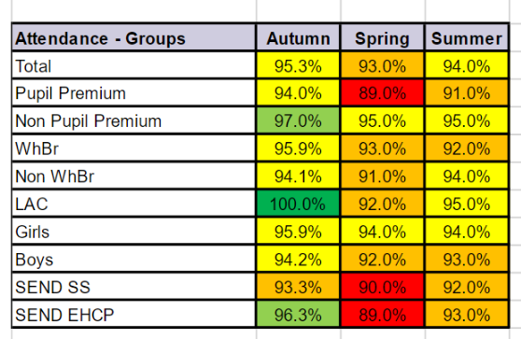

Externally provided programmes
Please include the names of any non-DfE programmes that you purchased in the previous academic year. This will help the Department for Education identify which ones are popular in England
Programme | Provider

Service pupil premium funding (optional)
For schools that receive this funding, you may wish to provide the following information:
Measure | Details
How did you spend your service pupil premium allocation last academic year? | N/A
What was the impact of that spending on service pupil premium eligible pupils?

Further information (optional)
Use this space to provide any further information about your pupil premium strategy. For example, about your strategy planning, or other activity that you are implementing to support disadvantaged pupils, that is not dependent on pupil premium or recovery premium funding.

