Computing Long-Term Plan 2022-2023
Equipping Children for a World of Possibilities

Computing - INTENT

Curriculum Intent: Equipping Children for a World of Possibilities.

Computing Intent: To nurture a child with high aspirations who feels safe and is prepared for a technology filled future. Through deepening their understanding and challenging their thinking by cultivating a computational mind capable of developing and using their learning confidently in everyday situations.

Computing - IMPLEMENT

Computing is taught initially through whole class sessions and then the children have chance to practise a key skill in groups/independently depending on skill.
Children are taught by their class teacher, they are taught the skills through both discrete blocks and those interwoven through the other curriculum areas.
Computing is taught each half term in each year group (but regularity in each year group is different depending on the theme or element of Computing being taught – might be taught a skill and practised through the half term or skills follow through in a unit of work). Online safety is taught through the year but a main block is taught discretely during Online Safety day in February.

Resources – Over the years a variety of coding resources have been purchased to give variety or each year group. Keyboards were purchased for the ipads to enable each year group (especially Year Two) to practise and hone their IT skills.
Ipads are used by all Year Groups across the majority of subjects.

Our ipads have become very old and unreliable and we no longer have a suite of computers. We had looked into getting a set of laptops up and running but IT support ran into lots of issues with this. As a final push we have put in a bid for new ipads as these are portable and we already have the docking stations to charge them installed from our older ipads. We have a small number of ipads that work but the apps are older versions. We are still waiting for news.

Computing - Long-term Plan (New for 2022) Introduction of Teach Computing Spring Term 2 2022

 | Autumn 1 | Autumn 2 | Spring 1 | Spring 2 | Summer 1 | Summer 2
Year R | 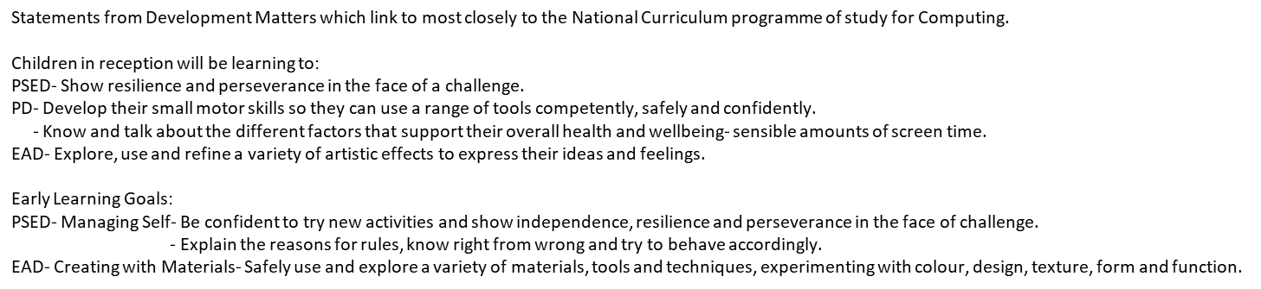
Year 1 | Moving a robot  Computer Science-  - They can understand what algorithms are and how they are implemented as programs on digital devices.  - They can understand that programmes execute by following precise and unambiguous instructions  - They can debug simple programs.  Digital Literacy  - To describe common uses of information technology beyond school  (Code a pillars and Beebots)  Technology Around Us  Digital Literacy  - To describe common uses of information technology beyond school  Information Technology  - Use technology purposefully to create digital content  - To use technology purposefully to organise digital content  - To understand and use Pic-colage  - To understand how to use an Ipad purposefully  - To navigate a keyboard effectively  (Dependent on hardware) |  | Digital Painting  Safer Internet Day 2022  Digital Literacy – Online Safety  - Use technology safely and respectfully  - To keep personal information private when using technology  - To know they should ask for help if they feel unsure about any online content or contact and who to ask  Information Technology  - Use technology purposefully to create digital content  - To use technology purposefully to organise digital content | Grouping Data  Information Technology  - Use technology purposefully to create digital content  - To use technology purposefully to organise digital content  Digital Literacy – Online Safety  - Use technology safely and respectfully  - To keep personal information private when using technology  - To know they should ask for help if they feel unsure about any online content or contact and who to ask | Programming animations  Computer Science-  - They can understand what algorithms are and how they are implemented as programs on digital devices.  - They can understand that programmes execute by following precise and unambiguous instructions  - They can debug simple programs. | Digital Writing  Information Technology  - Use technology purposefully to create digital content  - To use technology purposefully to organise digital content  Digital Literacy – Online Safety  - Use technology safely and respectfully  - To keep personal information private when using technology  - To know they should ask for help if they feel unsure about any online content or contact and who to ask
Year 2 | Information Technology around us  Digital Literacy – Online Safety  - To describe common uses of information technology beyond school  - Use technology safely and respectfully  - To keep personal information private when using technology  - They can explain to others how to stay safe online  Information Technology  - Use technology purposefully to create digital content  - They can use technology purposefully to retrieve digital content  - They can use technology purposefully to manipulate digital content  (Depending on hardware) |  | Digital Photography  Digital Literacy  - To describe common uses of information technology beyond school  - Use technology safely and respectfully  - To keep personal information private when using technology  - They can explain to others how to stay safe online  Information Technology  - Use technology purposefully to create digital content  - They can use technology purposefully to retrieve digital content  They can use technology purposefully to manipulate digital content  Safer Internet Day  Digital Literacy – Online Safety | Robot Algorithms  Computer Science-  - They can understand what algorithms are and how they are implemented as programs on digital devices.  - They can understand that programmes execute by following precise and unambiguous instructions  - They can debug simple programs.  Digital Literacy – Online Safety  - Use technology safely and respectfully  - To keep personal information private when using technology  - They can explain to others how to stay safe online | Pictograms  Information Technology  - Use technology purposefully to create digital content  - They can use technology purposefully to retrieve digital content  - They can use technology purposefully to manipulate digital content  Digital Literacy – Online Safety  - Use technology safely and respectfully  - To keep personal information private when using technology  - They can explain to others how to stay safe online | Making Music  Information Technology  - Use technology purposefully to create digital content  - They can use technology purposefully to retrieve digital content  - They can use technology purposefully to manipulate digital content  Programming Quizzes  Computer Science-  - They can understand what algorithms are and how they are implemented as programs on digital devices.  - They can understand that programmes execute by following precise and unambiguous instructions  - They can debug simple programs.  Information Technology  - Use technology purposefully to create digital content  - They can use technology purposefully to retrieve digital content  - They can use technology purposefully to manipulate digital content

