**Key Vocab:** **THEME** - **Superheroes, villain, hero, safe, unsafe, suit, cape, logo, utility belt. SCIENCE -wood, metal, plastic, fabric, water, rock. Senses, naming body parts. ART -Print, roll, press, block fill, Main art elements – shape, line, colour, Line - jagged, curved, thin, thick, bold, diagonal**

**Shape - cloud, jagged, bigger, smaller, Colour - primary colours, red, yellow and blue, contrasting. HISTORY – Heroes through history. COMPUTING – algorithms, programming, iPad, Piccolage, photograph. D&T – design, make, evaluate, costume, mask, drawing, template, textiles, straight lines, curved lines and shapes.**

**Superheroes**

**Autumn 1**

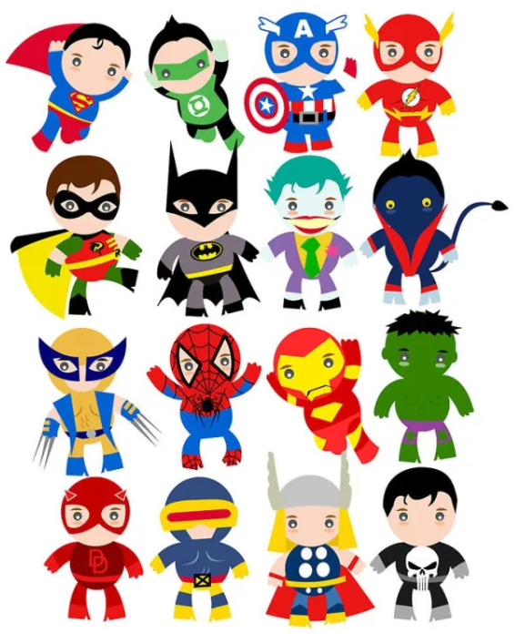

**Top 5 Facts: What should I know…**

* **Not all Superheroes have special powers.**
* **A superhero is a**[**fictional character**](https://wiki.kidzsearch.com/wiki/Fictional_character)**who protects innocent people and fights for good.**
* **Most superheroes keep their identities a secret by wearing masks or helmets.**
* **Superheroes can be real life heroes with everyday jobs.**
* **Nowadays a hero is someone who is courageous.**

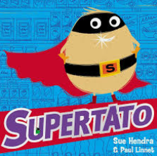 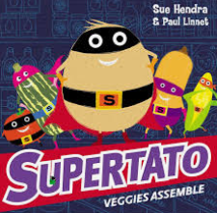 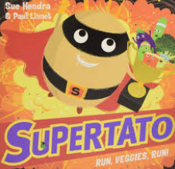 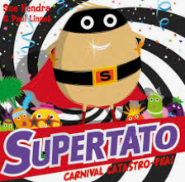 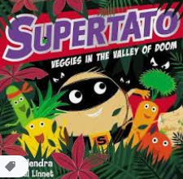 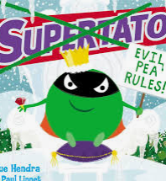

**Key Texts:**

**Key Question:**

* **What is a hero?**
* **What does it mean to be ‘Super’?**
* **What are Superpowers?**
* **Do all Superheroes have powers?**
* **What is a real-life hero?**
* **Who is your hero and why?**
* **What is wood, metal, fabric, water, plastic and rock?**
* **What is the best material for the job?**
* **What is a costume/logo/mask/cape?**
* **What is a design?**
* **How do we turn our ideas and designs into real objects?**
* **Who is Roy Lichtenstein and what is he famous for?**
* **Who is Sue Hendra and what is she famous for?**
* **What is a route and how do we use directions?**

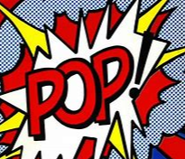

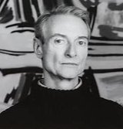

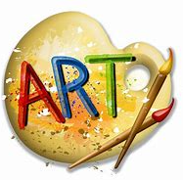

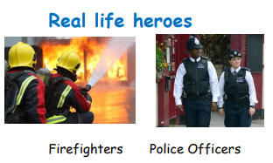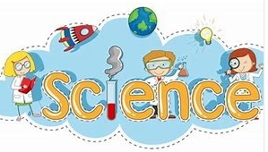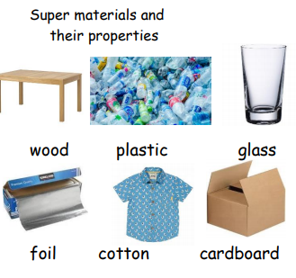

**Sue Hendra**

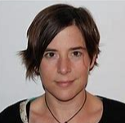

**Computing – Code-a-pillars**

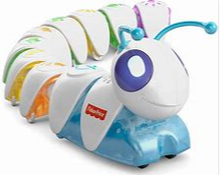

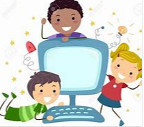

**directions**

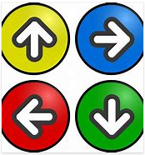

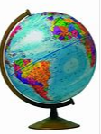

**Word Art**

**Roy Lichtenstein**